|  |  |  |  |  |  |  |  |  |  |  |  |  |  |  |  |  |  |  |  |  |  |  |  |  |  |  |  |  |  |  |  |  |  |  |  |
| --- | --- | --- | --- | --- | --- | --- | --- | --- | --- | --- | --- | --- | --- | --- | --- | --- | --- | --- | --- | --- | --- | --- | --- | --- | --- | --- | --- | --- | --- | --- | --- | --- | --- | --- | --- |
|  |  | Google Merchandise Store | | | | |  |  |  |  |  |  |  |  |  |  |  |  |  |  |  |  |  |  |  |  | [GO TO REPORT](https://analytics.google.com/analytics/web/?utm_source=pdfReportLink#/report/visitors-demographics-overview/a54516992w87479473p92324711/_u.dateOption=last30days&_.useg=builtin1,builtin2) | | | | | | | |  |
|  |  | 2 Test View | | | | |  |  |  |  |  |  |  |  |  |  |  |  |  |  |  |  |  |  |  |  |  |
|  |  |  |  | |  |  |  |  |  |  |  |  |  |  |  |  |  |  |  |  |  |  |  |  |  |  |  |  |  |  |  |  |  |  |  |
| **Demographics: Overview** | | | | | | |  |  |  |  |  |  |  |  |  |  |  |  |  |  |  |  |  |  |  |  |  |  |  |  |  |  |  |  |  |
|  |  | All Users | |  |  |  |  |  |  |  |  |  | New Users | | | |  |  |  |  |  |  |  |  |  | Sep 20, 2018 - Oct 19, 2018 | | | | | | | | |  |
|  |  |  |  |  |  |  |  |  |  |  |  |  |  |  |  |  |  |  |  |  |  |  |  |  |  |  |  |  |  |
|  |  | 100.00% Users | | | | |  |  |  |  |  |  | 90.50% Users | | | |  |  |  |  |  |  |  |  |  |  |  |  |  |  |  |  |  |  |  |
| Key Metric: | | | |  |  |  |  |  |  |  |  |  |  |  |  |  |  |  |  |  |  |  |  |  |  |  |  |  |  |  |  |  |  |  |  |
|  |  |  |  |  |  |  |  |  |  |  |  | |  |  |  |  |  |  |  |  |  |  |  |  |  |  |  |  |  | |  |  |  |  |  |
| Age | | | |  |  |  |  |  |  |  | 51.02% of total users | | | | |  | Age | | |  |  |  |  |  |  |  |  |  | 45.65% of total users | | | | | |  |
| 60% |  |  |  |  |  |  |  |  |  |  |  |  |  |  |  |  | 60% |  |  |  |  |  |  |  |  |  |  |  |  |  |  |  |  |  |  |
|  |  |  |  |  |  |  |  |  |  |  |  |  |  |  |  |  |  |  |  |  |  |  |  |  |  |  |  |  |  |  |  |  |  |
| 45% |  |  |  |  |  |  |  |  |  |  |  |  |  |  |  |  | 45% |  |  |  |  |  |  |  |  |  |  |  |  |  |  |  |  |  |  |
|  |  |  |  |  |  |  |  |  |  |  |  |  |  |  |  |  |  |  |  |  |  |  |  |  |  |  |  |  |  |  |  |  |  |
| 30% |  |  |  |  |  |  |  |  |  |  |  |  |  |  |  |  | 30% |  |  |  |  |  |  |  |  |  |  |  |  |  |  |  |  |  |  |
|  |  |  |  |  |  |  |  |  |  |  |  |  |  |  |  |  |  |  |  |  |  |  |  |  |  |  |  |  |  |  |  |  |  |
| 15% |  |  |  |  |  |  |  |  |  |  |  |  |  |  |  |  | 15% |  |  |  |  |  |  |  |  |  |  |  |  |  |  |  |  |  |  |
|  |  |  |  |  |  |  |  |  |  |  |  |  |  |  |  |  |  |  |  |  |  |  |  |  |  |  |  |  |  |  |  |  |  |
|  |  |  |  |  |  |  |  |  |  |  |  |  |  |  |  |  |  |  |  |  |  |  |  |  |  |  |  |  |  |  |  |  |
| 0% |  |  |  |  |  |  |  |  |  |  |  |  |  |  |  |  | 0% |  |  |  |  |  |  |  |  |  |  |  |  |  |  |  |  |  |  |
|  |  |  |  |  |  |  |  |  |  |  |  |  |  |  |  |  |  |  |  |  |  |  |  |  |  |  |  |  |  |  |  |  |  |
|  |  |  |  |  |  |  |  |  |  |  |  |  |  |  |  |  |  |  |  |  |  |  |  |  |  |  |  |  |  |  |  |  |  |
| 18-24 | | |  | 25-34 |  |  | 35-44 | 45-54 | | 55-64 | | 65+ | |  |  |  | 18-24 | | | 25-34 | | 35-44 | |  | 45-54 | | 55-64 | | | 65+ | |  |  |  |  |
|  |  |  |  |  |  |  |  |  |  |  |  |  |  |  |  |  |  |  |  |  |  |  |  |  |  |  |  |  |  |  |  |  |  |  |  |

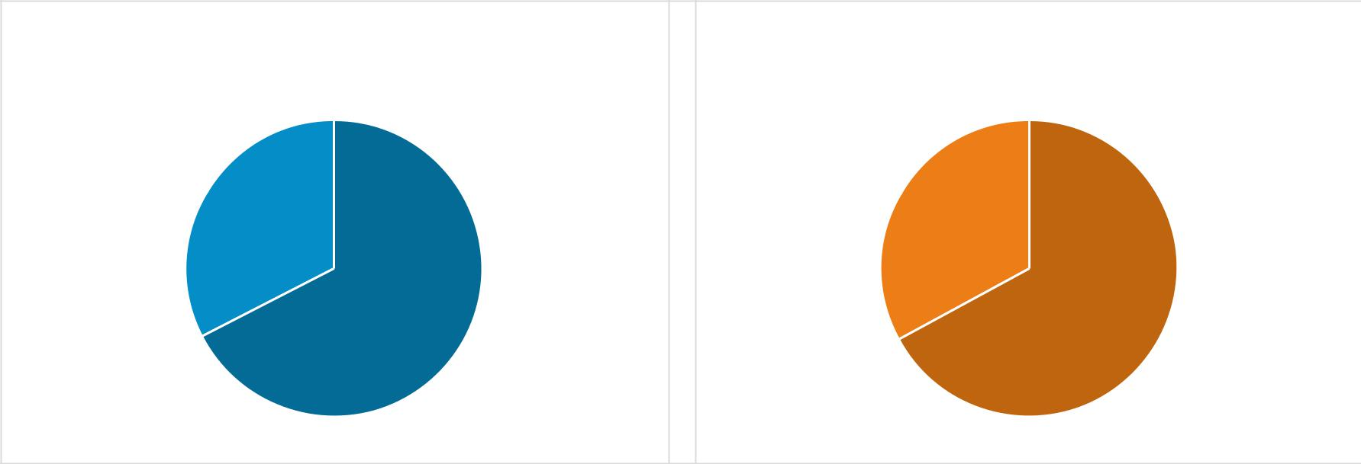

|  |  |  |  |  |  |  |  |  |  |  |  |
| --- | --- | --- | --- | --- | --- | --- | --- | --- | --- | --- | --- |
| Gender | | | | | 53.36% of total users | Gender | | |  | 47.82% of total users |  |
|  |  | male |  | female |  |  |  | male |  | female |  |
|  |  |  |  |  |  |  |
|  |  |  |  |  |  |  |

|  |  |
| --- | --- |
| 32.6% | 32.9% |

|  |  |
| --- | --- |
| 67.4% | 67.1% |